About: Vendor Information

Page Goal: Describe the preliminary process of Sanford Health forming business partnerships with organizations.

1). Header Banner
- Header Banner (required): 1375px by 298px
  - The banner image should not include any text
  - Medical Service Name_Component Name_Doctors Last Name (if included in the picture)_Image Size
- Header Banner – Cropped for Suggested Services Module (required): 690px by 402px
  - The banner image should not include any text
  - Medical Service Name_Component Name_Doctors Last Name (if included in the picture)_Image Size
- Headline (required): Service name
  - Text will always be white

Screenshot:

Copy/Image Needs | Copy/Image Provided
Header Banner (required)
Header Banner – Cropped for Suggested Services module (required)
Headline – Service Name (required) | Vendor Information

2). Call-To-Action Buttons
- Goal: highlight top actions you would like an individual to take when on this page, such as call to make an appointment or refer a patient
  - Button Text: 25-character maximum
    - Contact Us: Universal phone number for the service line that routes to all of the specific locations
  - Please provide URLs for each button

Screenshot:

Copy/Image Needs | Copy/Image Provided
Button 1 (required) | Contact us
Button 1 Link | (605) 312-4300
Button 2 (required)
Button 2 Link
Button 3 (not required)
Button 3 Link (not required)
Button 4 (not required)
Button 4 Link (not required)

3). Content/Service Line Description
- Goal: This section should clearly introduce visitors to explore partnerships with Sanford Health as a vendor. Specific educational material can be bulleted or highlighted in this section.
- Text Headline: recommended character maximum is 35 characters
  - Do not make the page headline the same as the text in the header banner, as this would be redundant
- Text: 500-2000 characters recommended (there is no section maximum character count)
  - Use an active voice: Be direct and energetic to keep the reader’s attention.
  - Write at a 7th to 9th grade level
  - Sentence Length: Aim to keep most sentences to 104 characters or less
  - Paragraph length: two-to-five sentences at most.
  - Break text into different headings: This will make it easier for people to find the exact content they are looking for and categorizes content so a patient is less intimated by the amount of copy on the page.
  - Use bulleted lists
- Call-To-Action: recommended 250 characters or less
  - Drive individuals to call to make an appointment

Screenshot:

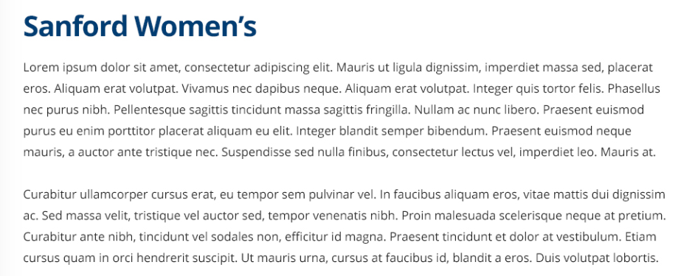

Copy/Image Needs | Copy/Image Provided
Text Headline (required) | Doing Business with Sanford Health
Text (required) | We set high standards of conduct, ethics and responsibility for our employees. We apply the same standards to our vendors.  We believe every vendor plays a role in our mission to provide health and healing – delivery personnel, representatives, technology providers and more. So we're careful to select suppliers who provide excellent service, value, cost-savings and innovation.  Every vendor approved to work with a Sanford Health hospital, clinic or facility must be registered and certified with us on an annual basis. (Fees apply.) We also have strict security policies to follow during on-site visits between all vendors and Sanford Health.  To learn more about becoming a vendor, read through the information here. Then contact us.  - Information for Sanford Health Suppliers  - Vendor Relations and Certification Program Overview  - Vendor Representative Certification Process  - New Product Introduction Process  - Vendor Relations and Certification Program  - Supply Chain Management Vendor Management Program  We look forward to learning more about your business.
Call-To-Action (not required, but recommended) | Before your first appointment, register your representatives with RepTrax. https://www.reptrax.com/

4). Location Tabbed Section – one to six carousel slides are available
- Goal: Highlight location content that is specific to vendor information. This information should expand on the other information on the page, but should not highlight a specific service page that is linked out in the navigation. This could lead an individual to download a file, watch a video or click through to an educational resource page.
  - Unit is recommended, but not required on the page
- Tab Name: 40-character max recommended
- Headline: 30-character max recommended
- Description: 600 characters maximum recommended
- Featured Carousel Content Options:
  - Videos and content about procedures, doctors or treatments that relate to the specialty page
  - Related advertising campaigns or initiatives
  - Highlights/information about new services or physicians
- Photo/Video – one per carousel slide (optional): 690px by 310px
  - Medical Service Name_Component Name_Doctors Last Name (if included in the picture)_Tab Name_Image Size
- Call-to-Action Button (optional): 20-character max
- URL (optional)
Screenshot:

Copy/Image Needs | Copy/Image Provided
Image/Video 1 (not required, but recommended)
Tab Name 1 (required) | Bemidji Region
Headline 1 (required) | Learn About Supplier Relations in Bemidji
Description 1 (required) | In Bemidji, all vendors are required to check in at a RepTrax kiosk at every visit to a Sanford Health facility. To learn more about becoming a Bemidji area vendor, download the policies below.
Call-to-Action 1 (optional) | Download Now
Call-to-Action URL 1.1 (optional) | https://www.sanfordhealth.org/~/media/sanford-health/pagefiles/sanford%20health%20orientation%20non%20employee%20bemidji.pdf?la=en
Call-to-Action URL 1.2 (optional) | https://www.sanfordhealth.org/~/media/sanford-health/pagefiles/or%20orientation%20bemidji%20specific.pdf?la=en
Call-to-Action URL 1.3 (optional) | https://www.sanfordhealth.org/~/media/sanford-health/pagefiles/bemidji%20kiosk%20locations.pdf?la=en
Image/Video 2 (not required, but recommended)
Tab Name 2 (required) | Fargo Region
Headline 2 (required) | Learn About Supplier Relations in Fargo
Description 2 (required) | In Fargo/Moorhead, all vendors are required to check in at a RepTrax kiosk at every visit to a Sanford Health facility. To learn more about becoming a Fargo/Moorhead area vendor, download the policies below.
Call-to-Action 2 (optional) | Download Now
Call-to-Action URL 2.1 (optional) | https://www.sanfordhealth.org/~/media/sanford-health/pagefiles/central%20processing%20surg%20ser%20instrumentation%20fargo.pdf?la=en
Call-to-Action URL 2.2 (optional) | https://www.sanfordhealth.org/~/media/sanford-health/pagefiles/sanford%20cardiac%20cath%20lab%20fargo.pdf?la=en
Call-to-Action URL 2.3 (optional) | https://www.sanfordhealth.org/~/media/sanford-health/pagefiles/sanford%20health%20orientation%20non%20employee%20fargo.pdf?la=en
Call-to-Action URL 2.4 (optional) | https://www.sanfordhealth.org/~/media/sanford-health/pagefiles/corp%20fargo%20kiosk.pdf?la=en
Image/Video 3 (not required, but recommended)
Tab Name 3 (required) | Sioux Falls Region
Headline 3 (required) | Learn About Supplier Relations in Sioux Falls
Description 3 (required) | In Sioux Falls, all vendors are required to check in at designated locations at every visit to a Sanford Health facility. To learn more about becoming a Sioux Falls area vendor, download the policies below.
Call-to-Action 3 (optional) | Download Now
Call-to-Action URL 3.1 (optional) | https://www.sanfordhealth.org/~/media/sanford-health/pagefiles/operating%20room%20sf%20instrumentation%20vendor%20requirements.pdf?la=en
Call-to-Action URL 3.2 (optional) | https://www.sanfordhealth.org/~/media/sanford-health/pagefiles/or%20orientation%20specific%20sf.pdf?la=en
Call-to-Action URL 3.3 (optional) | https://www.sanfordhealth.org/~/media/sanford-health/pagefiles/sanford%20health%20orientation%20non%20employee%20sf.pdf?la=en
Image/Video 4 (not required, but recommended)
Tab Name 4 (required) | Thief River Falls Region
Headline 4 (required) | Learn About Supplier Relations in Thief River Falls
Description 4 (required) | In Thief River Falls, all vendors are required to check in at a RepTrax kiosk at every visit to a Sanford Health facility. To learn more about becoming a Thief River Falls area vendor, download the policies below.
Call-to-Action 4 (optional) | Download Now
Call-to-Action URL 4 (optional) | https://www.sanfordhealth.org/~/media/sanford-health/pagefiles/sanford%20health%20orientation%20non%20employee%20trf.pdf?la=en
*Please add additional rows for each tab that is highlighted in this unit

